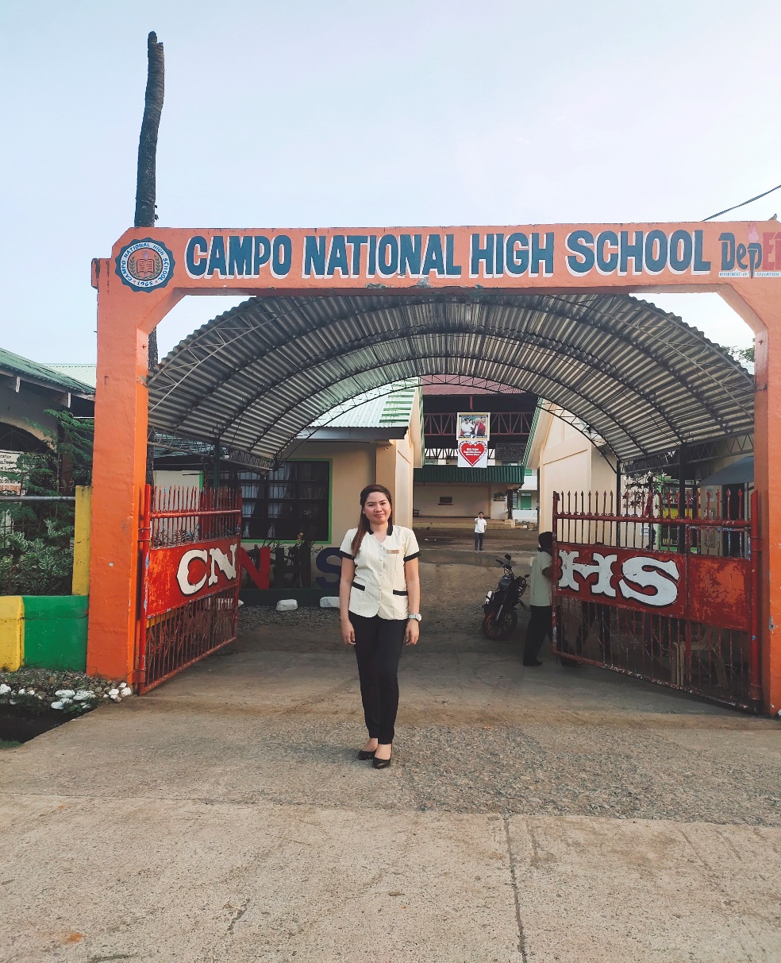

**WELCOME TO MY TEACHING PORTFOLIO!!**

My name is Christine R. Loon, from Cab-ilan, Dinagat, Dinagat Province, a loving daughter of Mr. Luvenario and Mrs. Flora Loon. I have two siblings namely Irish L. Santiago my sister and Jhundi R. Loon our youngest brother. A graduate of Bachelor of Science in Customs Administration in Saint Jude Thaddeus Institute of Techonology Surigao. Now currently earning units and taking up Teacher Certificate Curriculum (TCC) at Surigao State College of Technology, for me to take the Licensure Examination for Teachers major in Social Science. My areas of interest are computer technology, history, and music where I found love to them, that’s why I want to pursue this life path of mine to teach and to share my knowledge and experiences in life.

I’m friendly and easy to go with, I have a lot of friends and I want more of it. With this life journey I’m hoping that I can meet new people and sharing how beautiful life is.

For me teaching is not an easy career in life you must have a big heart and a strong determination in life because every student is a unique individual which possess different characteristics in life. Teaching is both a vocation and a mission. Responding to a God’s call is not a simple task and gets even harder when you will do the mission of being the catalyst for change. Yet, touching one’s life is priceless and molding them into the best of what can be is the hardest job, but rewarded.

A teacher has a dedication which inspire to some students even how it’s hard for them to mold a certain child into a better one. To teach them every day and give patience as to those who did not value their sacrifices, because a teacher shall maintain at all times a dignified personality which could serve as model worthy of emulation by learners, peers and others. And I feel in love in teaching that’s why I want to be a teacher if God grant my dream to become one.

TEACHING PHILOSOPHY

Every teacher brings his or her own set of values into the classroom. Here are four of the most important aspects to my teaching philosophy:

***EQUITY:***

Each child is unique and has his or her own set of circumstances, experiences, and needs. As a teacher, it is crucial to work diligently in making sure each child’s individual needs are met and their goals, attainable. Differentiation is an important toolset that I believe should be in every teacher’s repertoire.

***CHILD-CENTERED LEARNING:***

Learning in the classroom should be experiential, authentic, organic, hands-on, and inquiry driven. Children should be able to share their learning experiences through peer interaction and play. I both developmentally appropriate and sparks a love for life-long learning.

***COMMUNITY BUILDING:***

I emphasize the importance of teaching all aspects of the curriculum in a way that children will care about the community around them. I want to build a community in the classroom that is shaped by the diverse needs of each and every student. I want both students and parents to feel empowered!

***RISK-TAKING ENVIRONMENT***:

I think that one of the most important things in the school is for the children to feel comfortable and safe enough in their environment to participate without the risk of being rejected or penalized.

My observation about the school environment and neighborhood of Campo National High School, it was rural area where more than half of the people living there were farmers and other are having their fishponds as their source of income. The school is surrounded by rice fields. The income level of the families living in the community ranges from low to average income earning families.

The campus itself is not accessible to public transportation. Some students have their own motorcycle so that they can easily go home. Some parents also fetch them during break time, others also are commuters paid for their everyday consumption. The campus buildings are still usable, showing no signs of decay but proper maintenance could be done like repainting and refurbishing, new buildings are being constructed to accommodate the growing population. The administrative offices are easy to locate, when one is a first timer in visiting the school campus. It was convenient also for visitors, since most offices can be located in one building and across another building.

Walking around the school campus, the environment was friendly, knowing high school students, they’re rowdy, but it was not the case because of their age. I recall my experience. when I was just the same with their age, I am also curious about some things, I want to explore some things that is new to me. I’m optimistic, rowdy, and confused. Some also are polite and very kind.

During my practice in Campo National High School, at first I feel nervous if what should I do in class, but my resource teacher help me and boost my confidence in doing some great strategies on how to deal with students especially in classroom management. First time was a great day for me because my students help me by cooperating and participating in class especially in doing group activities. I found out that every one of them possess a unique character traits which depends largely on their background. They have diverse backgrounds and each of them is an individual by their own rights.

My resource teacher focus on their learning and behavior, at their age it is expected that management can be unruly most of the time. A very profound sense of patience and humility, understanding to earn them respect and trust. Their behavior is basically based on instinct, needs and wants. Their impulse is to satisfy that need or wants. The learners can be trusted to make their own decisions, formulate their ideas to a certain degree that it can be manipulated and controlled. A controlled environment to avoid unnecessary uncalled for situations. Since their span of attention is limited, constant guidance and care is tolerated at maximum level. They have their way of concentration, so the best way to acknowledge them to concentrate is through their own language, their interests, hobbies, and needs and wants in what they want to do or become in the future.

I’m handling four subjects during my teaching practice in the said school. First I have Filipino 9, then Araling Panlipunan 9, Science 9, and lastly English 10. It was a challenging task for me because I don’t have any teaching experiences and I don’t know how to manage every student especially coping with their interests. But a big thank you to my cooperating teachers which give their ample time and knowledge especially in doing guiding on how to write my lesson plan and to be an effective in that matter.

My journey in practice teaching

“LEARNING AND TEACHING SHOULD NOT STAND ON OPPOSITE BANKS AND JUST WATCH THE RIVER FLOW BY; INSTEAD, THEY SHOULD EMBARK TOGETHER ON A JOURNEY DOWN THE WATER. THROUGH AN RECIPROCAL EXCHANGE, TEACHING CAN STRENGTHEN LEARNING HOW TO LEARN.”

Practice teaching is one of the most awaited parts of every pre-service teaching journey. It is a life changing opportunity as it gives meaning to all rigorous academic preparations that went through the days I been there. As one who is almost done with these stuffs, I felt excited at first until I finally started practicing my chosen career.

November 15, 2019, was the day of our deployment at Campo National High School. It was exciting yet uneasy. Day to day moments that you open your eyes and it still dark outside and I’m still sleepy is like putting chili on top of an ice cream. You still have to eat it because at the bottom of the cone, there stays the sweet snowy cream that you have wanting for. This experiences tested my faith on my decision. Often that I ask myself, “Do I really want this?” and often that wrinkle occur on the space between my nose and my eyebrows. However, with all those shillyshallies, I never compromised my students to learn. As much as possible, I have to give all the knowledge that they deserve to have within that day. Strong determination is the one that lead me to finish my practice.

To provide them with such accurate information is not an easy task especially in Campo National High School has the main problem which is the source of communication. There is no signal in that said place, so it is very hard for me to research all the things that my student will have to. In that instance I used my resources to find another strategy so that I can give them the things they need to learn. Natural occurrences that they have to understand and most importantly is to help them find the teacher within themselves.

Practice teaching trained me to read more books. I accepted the truth that I AM LIMITED but I CAN EXTEND BEYOND. The quest of knowledge is after all infinite and with a teacher being a student. It is also very rewarded if your students learned a lot from you. Teaching is difficult. You’re going to have rough days, and you’re going to need help sometimes. So in this sense I make myself friendly at all times, in all teaching and non-teaching staff. Not only making friends can prove to help you as a teacher, but it can also make your day more fun.

It was a great experience. And I really love to become one of the best teacher someday.

My LIFE MAP:

**10 YEARS...**Pursuing my doctorate degree and live happily with my own family.

**2 YEARS FROM NOW…**I’m a licensed teacher and already teach in DEPED

**5 YEARS...**I have my master’s degree.

**NOW**… I’m pursuing my goals to become one of the best teacher.

**CHRISTINE R. LOON**

BRGY. CAB-ILAN, DINAGAT, DINAGAT ISLANDS

09505537623/christineloon@ymail.com

**December 16, 2019**

**MRS. ELIZA B. ESCABAL, SHS Principal III**

**CAMPO NATIONAL HIGH SCHOOL**

**BRGY. CAMPO, BACUAG, SURIGAO DEL NORTE**

**Dear ma’am Escabal,**

Good Day!! It is with great pleasure that I am working to secure a secondary teaching position within your school district. I believe that my instructional abilities, combined with my strong interpersonal skills and work ethic would greatly benefit your educational program.

I believe that education is the key to success for young students. As a teacher, I hope to motivate students in ascertaining their inner strengths and abilities and discovering what truly inspires them. I aim to provide a stimulating learning environment that encourages students to trust their own opinions, while fostering confidence in order for students to realize their full potential.

Through my teaching experiences thus far, I have found the method of facilitating rather than dictating to be a highly beneficial style of teaching. I have learned that if students construct their own learning experiences they will not only retain information longer, but they will also become more confident in their abilities. Being devoted to this assertion confirms that I have made right career choice for myself. I love working with children and will continue to strive to be positive influence in their lives.

I have come to realize how vital education is in the preparation of young people to achieve success in all endeavors set before them. I hope to instill a love learning and a desire for constant knowledge within each student.

Please contact me at your convenience to set up a meeting so that we may discuss in greater detail how my qualifications would best meet the needs of your educational program. Thank you for your time and considering my application.

**Sincerely,**

**Christine R. Loon**